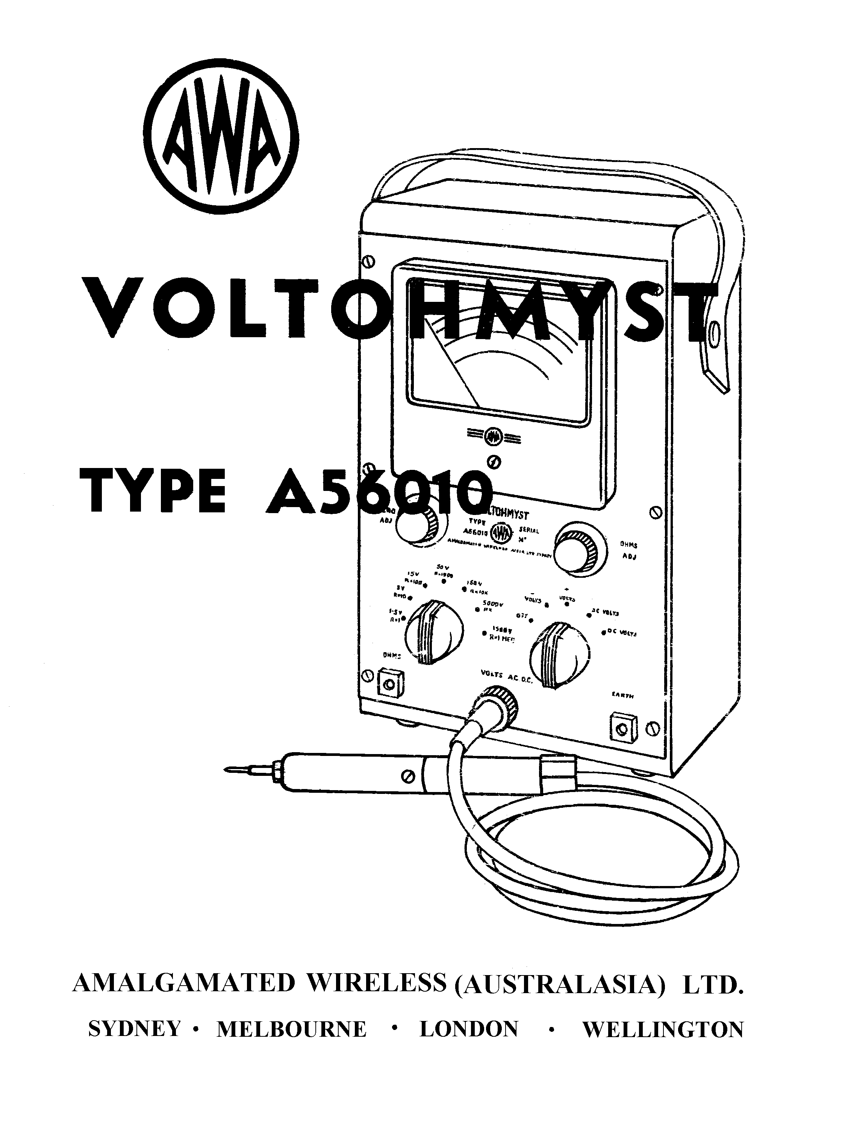

Instruction Book 2-56010R

A.W.W. VOLTOHMYST TYPE A56010

(Serial No. 153 onwards)

Amalgamated Wireless (Australasia) Limited

47 York Street,

SYDNEY

1-56010R (i)

INDEX

SECTION Page No.

1. DESCRIPTION:
1.1 Application 1
1.2 Mechanical Construction 3
1.3 Design Characteristics and Circuit Description 3
1.4 Summary of Controls, Facilities and Electrical
Characteristics 6
1.4.1 Facilities 6
1.4.2 Controls and Input Connections 7
1.4.3 Electrical Characteristics 7
1.5 Probes and Cables used with the Voltohmyst A56010 9
1.5.1 Cables and Probes Supplied with the Instrument 9
1.5.2 Probes Not Normally Supplied with the Instrument. 10

2. METHOD OF USE:
2.1 Warning Notes 13
2.2 Setting up Procedures 14
2.3 D.C. Voltage Measurement 14
(using D.C. and Direct Probes)
2.4 Centre-zero Readings 15
2.5 A.C. Voltage Measurement
(With Direct probe alone) 15
2.6 Resistance Measurement 16
2.6.1 Normal Measurement of Resistance
up to 1,000 M.ohm 16
2.6.2 High resistance (insulation) Measurement 16
2.7 Current Measurement 17
2.8 Measurement and Calculation of dbm 17

3. MAINTENANCE:
3.1 Valve Replacement 19
3.2 Checking the Condition of the 1.5V. cell 19
3.3 Electrical Balance Check 19
3.4 Calibration 20
3.4.1 D.C. Calibration 20
3.4.2 A.C. Calibration 21
3.4.3 A.C. Compensation Adjustment (C2) 21

4. COMPONENT SCHEDULE: 23

5. DIAGRAMS:
Voltohmyst A56010 Drg. No. Fig. No.
Circuit 5601002 7
Probes and Cables used with Voltohmyst 56010D7 8

